Interns Testimonials
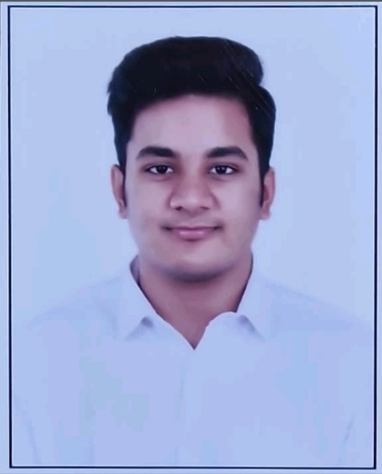
- Khushal Karnani- I am writing to share my experience as a Finance Intern at UDAAN Society. It has been a highly enriching and valuable journey for me.
During my internship, I worked on four different proposals along with their respective budgets. This experience significantly improved my understanding of budget preparation, cost estimation, and proposal structuring. The practical exposure I gained has contributed greatly to my academic and professional development.
I sincerely appreciate the guidance, support, and opportunity provided to me throughout this internship. The learning environment was very positive and made the entire experience both comfortable and motivating. I truly enjoyed working on the assignments and gained meaningful insights during my time here.
(Student of Maharaja Agrasen Institute of Management Studies, Delhi (BCom honours))


- Nisarga R Malap- My internship experience was very valuable and practical. It helped me strengthen my skills in web development, backend integration, database management, UI/UX improvement, chatbot setup, testing, documentation, and teamwork. I also gained exposure to real-world project planning, requirement analysis, and knowledge transfer, which improved both my technical confidence and professional communication.
(Student of Parul Institute of engineering and technology)

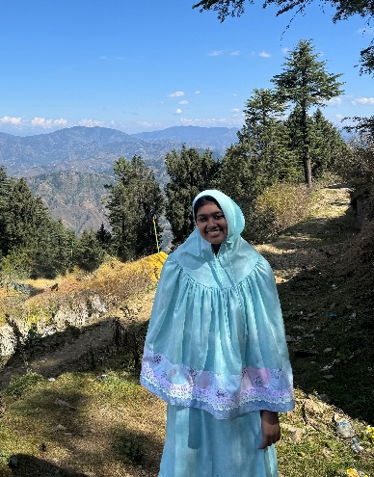
- My name is Amatullah Jamalee from Tanzania, I am a student of Symbiosis Center for Media and Communication pursuing BBA Media Management
My experience working at UDAAN Society as an intern was very nice, during this internship, I learned how a professional workplace functions and improved my communication and teamwork skills. This experience helped me gain practical knowledge and confidence.

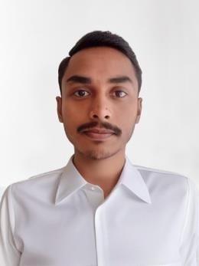
- I am Mohammad Asif, a B. Tech student specialising in Computer Science and Engineering (Data Science) at ABESIT Group of Institutions, Ghaziabad. I am passionate about data analysis and its potential to drive meaningful change in society, especially in the education and social development sector.

During my internship at UDAAN Society, I had the opportunity to work on the Shiksha Plus dataset related to the Adult Literacy Program. I performed data cleaning, removed duplicate entries, corrected data formats, and organised the data for meaningful analysis. I also generated analytical reports, dashboards, and insights that supported program performance evaluation and decision-making. This experience deepened my understanding of how data can empower social organisations to create greater impact.

